10-Port Unmanaged Ethernet Switch
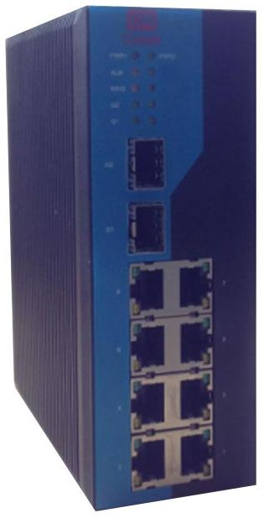
- 4~8*100M RJ45 ports, Auto-Negotiation speed, auto Full/Half Duplex Mode, auto MDI/MDI-X connection
- 0~4*100M full Duplex fiber ports, Default SC port, FC/ST optional, max to 120km
- 0~2*1000M SFP ports, 1000M optic fiber or RJ45 interface module optional
- High strength metal shell with IP40 protection, EMC industrial level 4 supported
- Wide range voltage redundant dual inputs, full-load power consumption < 11W
- DIN-Rail Mounting and Wall Mounting supported
- Standard operating temperature -40~85℃to satisfy harsh industrial environment

Product Overview

10-Port Unmanaged Ethernet Switch is designed with IP40 protection metal housing, and supports EMC industrial level 4, redundant dual inputs with wide range voltage(12~48V DC), 4~8*10/100BaseT(X) RJ45 ports and 0~2*1000M SFP ports and 0~4*100BaseFX fiber ports combined flexibly, DIN35 rail or wall mounting for different industrial circumstances.

Features

- IEEE802.3/802.3u/802.3ab, store-and-forward switching
- 4~8*10/100BaseT(X) RJ45 ports, Auto-Negotiation speed(10M/100M),auto Duplex mode and MDI/MDI-X connection
- 0~4*100BaseFX 100M full Duplex fiber ports (default SC port, FC/ST optional), max to 120km
- 0~2*1000M SFP port, 1000M optic fiber or RJ45 interface module optional
- Metal housing with IP40 protection and EMC industrial level 4
- Wide range power voltage with 12~48V DC inputs, full load power consumption less than 11W
- Working temperature range of -40~85℃

Interfaces
- RJ45 port: 10/100BaseT(X) auto negotiate speed, Full/Half Duplex, MDI/MDI-X connection
- Fiber port: 100BaseFX 100M full Duplex (default SC port, FC/ST optional), max to 120 km
- SFP port: 1000M SFP port, 1000M optic fiber or RJ45 interface module optional
- Power: Dual inputs, 2 pluggable four pins power terminal
Exchange Property
- Ten trillion forwarding speed:14881pps
- Fast forwarding speed:148810pps
- Gigabit forwarding speed: 1488095pps
- Transmission way:Store-and-forward.
- Switching bandwidth:5.6Gbps
- Buffer memory size:1Mbits
- MAC address table:8K

Specifications
Power Requirements
- Dual redundant inputs with wide range voltage ( 12~48V DC ), typical 12V/24V/48V
- Full load power consumption less than 11W
- Overload-Current protection
Physical Characteristics
- Dimensions (W×H×D ): 50mm×150.5mm×125.5mm
- Weight: 900 g
- Housing: Metal, IP40 protection
- Installation: Wall mounting or DIN rail mounting
Environment Limits
- Work Temp.: -40℃~85℃
- Storage Temp.: -40℃~85℃
- Relative Humidity: 5%~95% (non-condensing)
Warranty
- Warranty Period: 5 years

Standards and Certifications

- IEC61000-4-2(ESD): ±6KV touch, ±15KV atmosphere
- IEC61000-4-3(RS): 10V/m (80-1000MHZ)
- IEC61000-4-4(EFT): power cable ±2/4KV, data cable ±2KV
- IEC61000-4-5(Surge): power cable ±4KV CM/±2KV DM, data cable: ±4KV
- IEC61000-4-6(CS): 3V (10KHZ-150KHZ), 10V ( 150KHZ-80MHZ)
- IEC61000-4-8(MS): 100A/M COUNT 1000A/M, 1S TO 3SI
- IEC61000-4-12/18(HFRD): 2.5KV CM, 1KV DM
- IEC61000-4-10(DP): 30A/M
- IEC61000-4-16(CM): 30V COUNT 300V, 1S
- IEC61000-6-2, IEC61850-3, IEEE1613
- EN50121-4
Dimensions(mm)

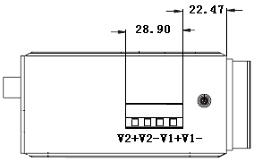
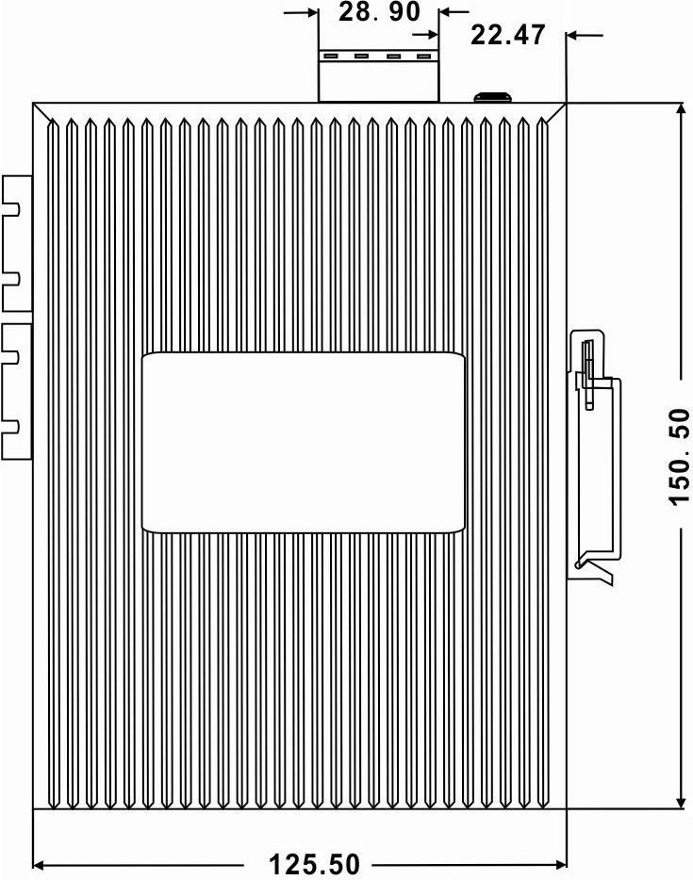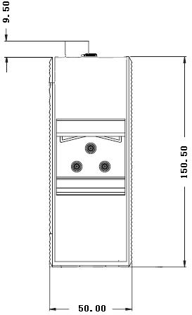
Models Series

Model | Specs
Ck2080 | 8*10/100BaseT(X) RJ45 ports, DIN35 rail mounting
Ck2071 | 7*10/100BaseT(X) RJ45 ports, 1*100BaseFX fiber port, single-mode/multi-mode, DIN35 rail mounting
Ck2062 | 6*10/100BaseT(X) RJ45 ports, 2*100BaseFX fiber ports, single-mode/multi-mode, DIN35 rail mounting
Ck2044 | 4*10/100BaseT(X) RJ45 ports, 4*100BaseFX fiber ports, single-mode/multi-mode, DIN35 rail mounting
Ck3080 | 8*10/100BaseT(X) RJ45 ports, 2*1000M SFP slots(optical/electrical interface optional, transceiver module not included), DIN35 rail mounting
Ck3071 | 7*10/100BaseT(X) RJ45 ports, 1*100BaseFX fiber port, single-mode/multi-mode, 2*1000M SFP slots(optical/electrical interface optional, transceiver module not included), DIN35 rail mounting
Ck3062 | 6*10/100BaseT(X) RJ45 ports, 2*100BaseFX fiber ports, single-mode/multi-mode, 2*1000M SFP slots(optical/electrical interface optional, transceiver module not included), DIN35 rail mounting
Ck3044 | 4*10/100BaseT(X) RJ45 ports, 4*100BaseFX fiber ports, single-mode/multi-mode, 2*1000M SFP slots(optical/electrical interface optional, transceiver module not included), DIN35 rail mounting

Package List

- 10-Port Unmanaged Industrial Ethernet Switch with industrial power terminal
- Product Manual
- Product Warranty

